**Requirement Specification Document for RedBox System**

**Team Members:**

**Dan Hammond (u0697475)**

**Richard Hall (u0509858)**

**Deepti Deshpande (u0872493)**

Table of Contents

**Project Drivers** 3

Purpose of the Project: 3

Content: 3

Motivation: 3

Scope of the project: 3

Goals of the Project: 3

Stakeholders: 4

Current vs. Future state: 5

Current State: 5

Future State: 5

**Project Constraints** 5

Constraints: 5

Assumptions: 6

Risks: 6

**Diagrams** 7

Context Diagram: 7

Data Flow Diagram: 7

Activity Diagram: 8

Use Case Diagram: 9

**Requirements** 10

User Stories: 10

Business Event Table: 10

Business Use Case Scenarios: 11

Functional Requirements: 15

Non-Functional Requirements: 18



**Redbox system**

**Project Drivers**

Purpose of the Project:

Content:

To build a fully functional Redbox kiosk which will allow users to rent a movie or a video game at any time? These kiosks will be located at all major grocery stores, pharmacies, mass retailers, convenience stores, gas stations and fast food restaurants.

Motivation:

The business market of renting the movies/games is growing at a tremendous rate. We would like to utilize this opportunity and come up with conveniently located and easy to use kiosks for renting movies/games.

Scope of the project:

The scope of the project is limited to renting of movies/games from Redbox and the user would not be able to buy movies/games. The user would not be able to stream movies/games from the kiosk. The user will be able to rent only those movies, which are available in English.

Goals of the Project:

* Make the rental process of movies/games convenient - Users will be able to use Redbox kiosk easily. The process of renting or returning the movie will not take up more than 10 minutes of user’s time.
* Affordable - All movies/video games shall be available to rent at 1 USD.
* Easy to rent anywhere and anytime - The Redbox kiosks will be located at all the major grocery stores, pharmacies, mass retailers, gas stations, convenience stores and fast food restaurants which will make it easier to rent movies anywhere and anytime

Stakeholders:

|  |  |  |  |  |  |
| --- | --- | --- | --- | --- | --- |
| ID | Stakeholder | Role | Influence | Needs | Notes |
| 1 | Chief Executive Officer | Decision Maker, Director, Manager, Leader | High | Deadlines, Profit |  |
| 2 | Shareholders | Sponsor | High | Profit |  |
| 3 | Manufacturers | Designers and Developers of Redbox kiosk | Medium | Requirement Specifications |  |
| 4 | Programmers | Software Engineers and Testers of Redbox kiosk software | Medium | Requirement Specifications |  |
| 5 | Lawyers | Legal Experts | Medium | Requirement Specifications that comply to law, liabilities, copyrights |  |
| 6 | Production Houses | Sell the distribution and copyrights rights of the movies to Redbox | Medium | Copyrights agreements |  |
| 7 | Game Companies | Sell the distribution and copyrights rights of the game to Redbox | Medium | Copyrights agreements |  |
| 8 | Movie Lovers | Prospective Customer | High | Popular Movies |  |
| 9 | Game Lovers | Prospective Customer | High | Popular Games |  |
| 10 | RedBox Accountants | Oversee all the account related activities of Redbox | Medium | Cost Sheets, Requirement Specifications |  |

Current vs. Future state:

Current State:

The current state of the Redbox system allows for customers to rent english movies and games for $1.00. Kiosks are placed in different locations in order to allow customers easy and quick access in a convenient location. However, some locations are not accessible at any given hour.

Future State:

The future state of the Redbox System will allow users to rent movies in foreign languages. It will have additional feature which will allow users to stream movies online. In addition to that, the future state of Redbox system will allow users to rent DVDs of different TV series.

**Project Constraints**

Constraints:

* **Description:** The product shall be confined to a limited enclosure.

**Rationale:** Suppliers must be able to fit system in a locations that will not affect the normal business flow for that location.

**Fit criterion:** All product must fit in a 2 ft. by 4 ft. enclosure.

* **Description:** The product must be able to withstand the natural elements

**Rationale:** The system can be placed in a location that is not open 24 hrs. a day and still be able to be accessible by the customers.

**Fit criterion:** The product must be able to function up to -25 degrees F and under 6 m of water.

* **Description:** The product must be operational 24 hrs. a day.

**Rationale:** If the host location for the system is open 24hrs a day, the unit must also be operational during that time.

**Fit criterion:** The product must be able to functional at full capacity for at least a whole week.

Assumptions:

* When the product is returned, it is in prime operating condition.
* The system will have a wireless connection to Verizon Wireless to enable the system to send and receive information.
* The customer will have a working credit or debit card in which to draw funds.
* The system will be compatible with the current version of Mac and Windows software.

Risks:

* Customers might not return DVD’s/Games
* Customers might not like the selection of Games/Movies
* Might not be able to find enough locations to place it
* Customers might find other ways to get their movies eg. Netflix, Hulu
* Funding might not be available
* Machines might malfunction
* Customers might scratch DVD/Game
* Demand may drop resulting in loss in sales
* Movie/Game companies might not allow the renting of their products
* Customers might duplicate the DVD preventing further sales

# **Diagrams**

## Context Diagram:

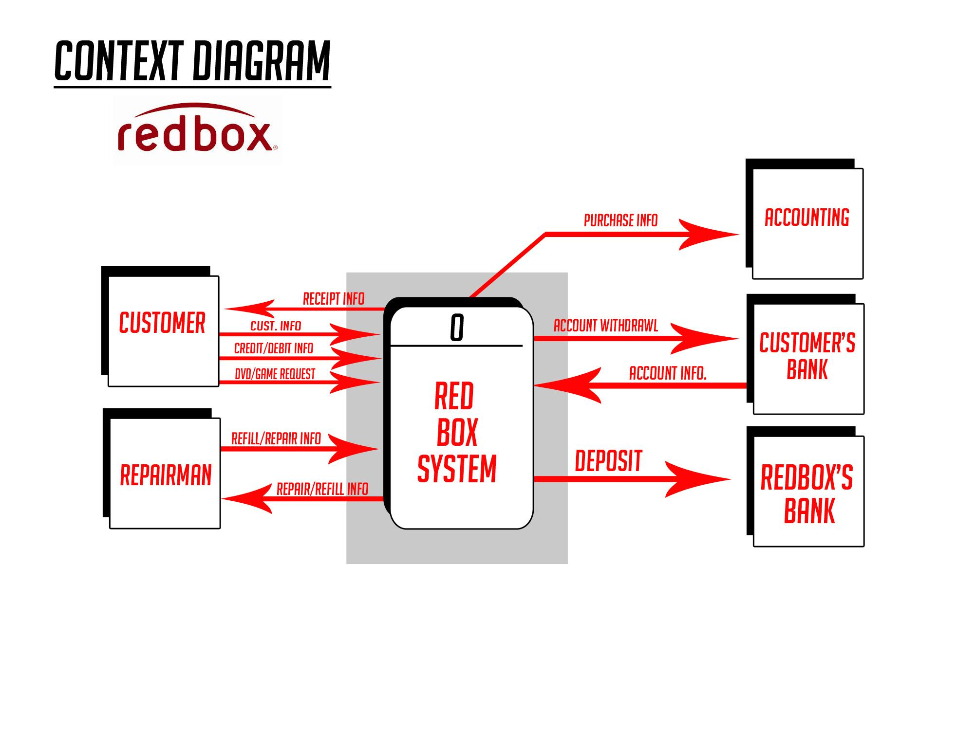

Data Flow Diagram:

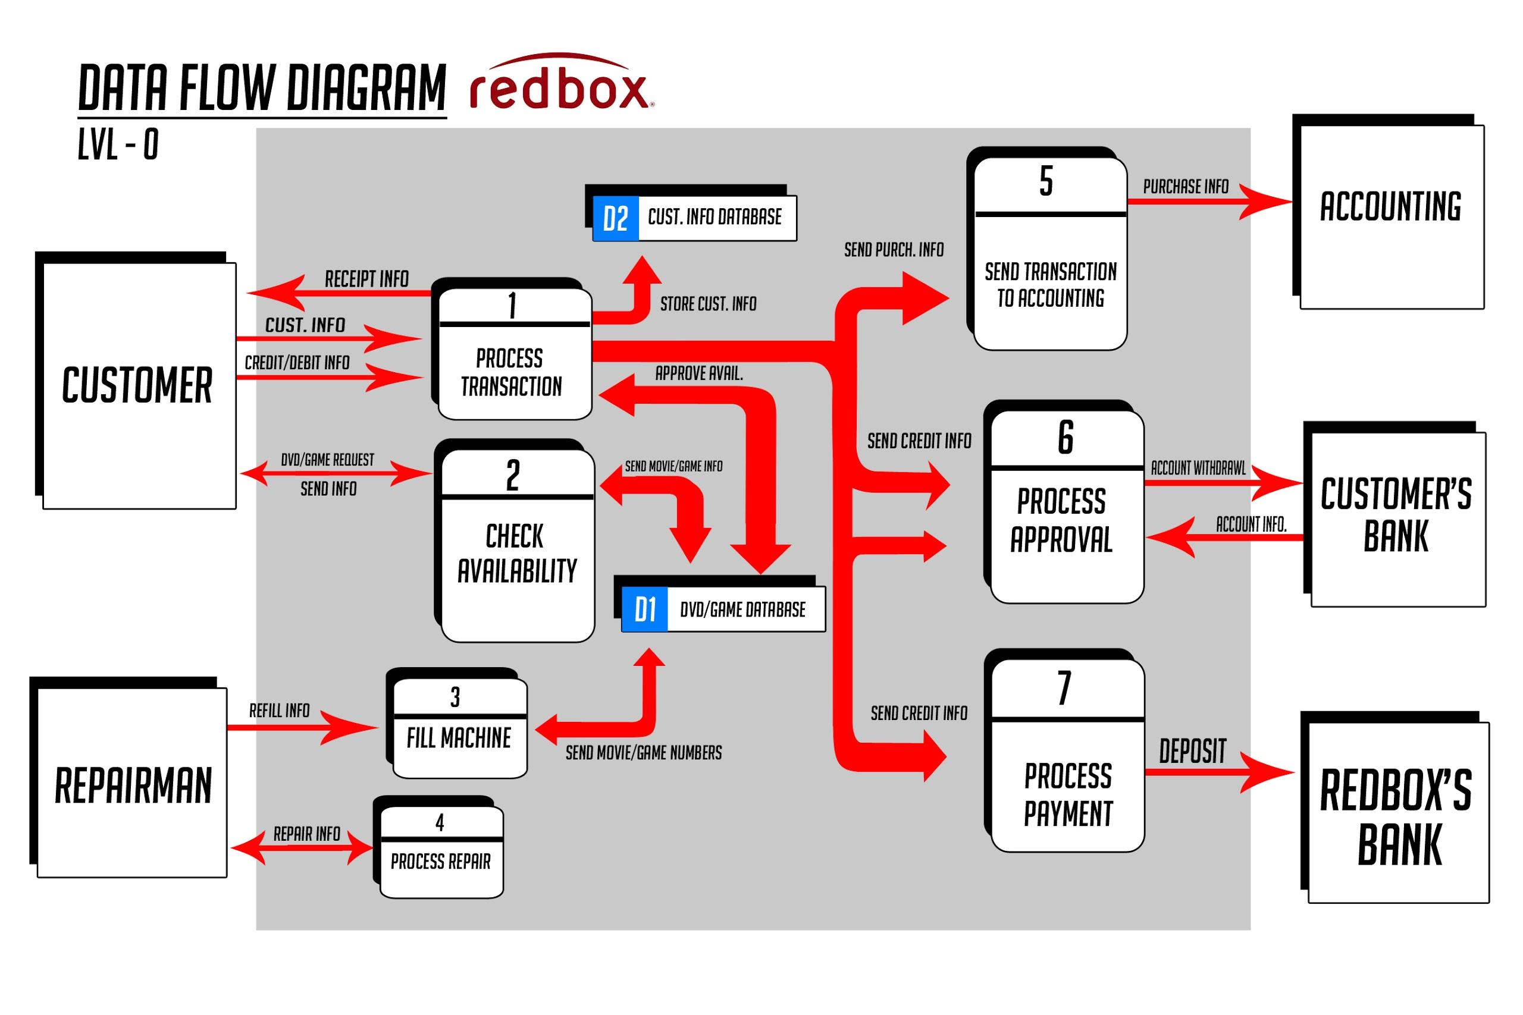

Activity Diagram:

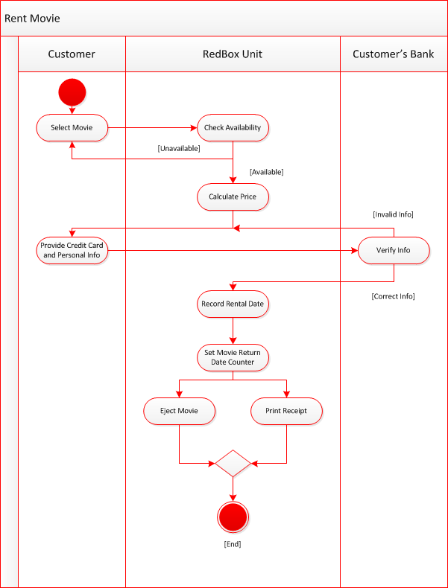

Use Case Diagram:

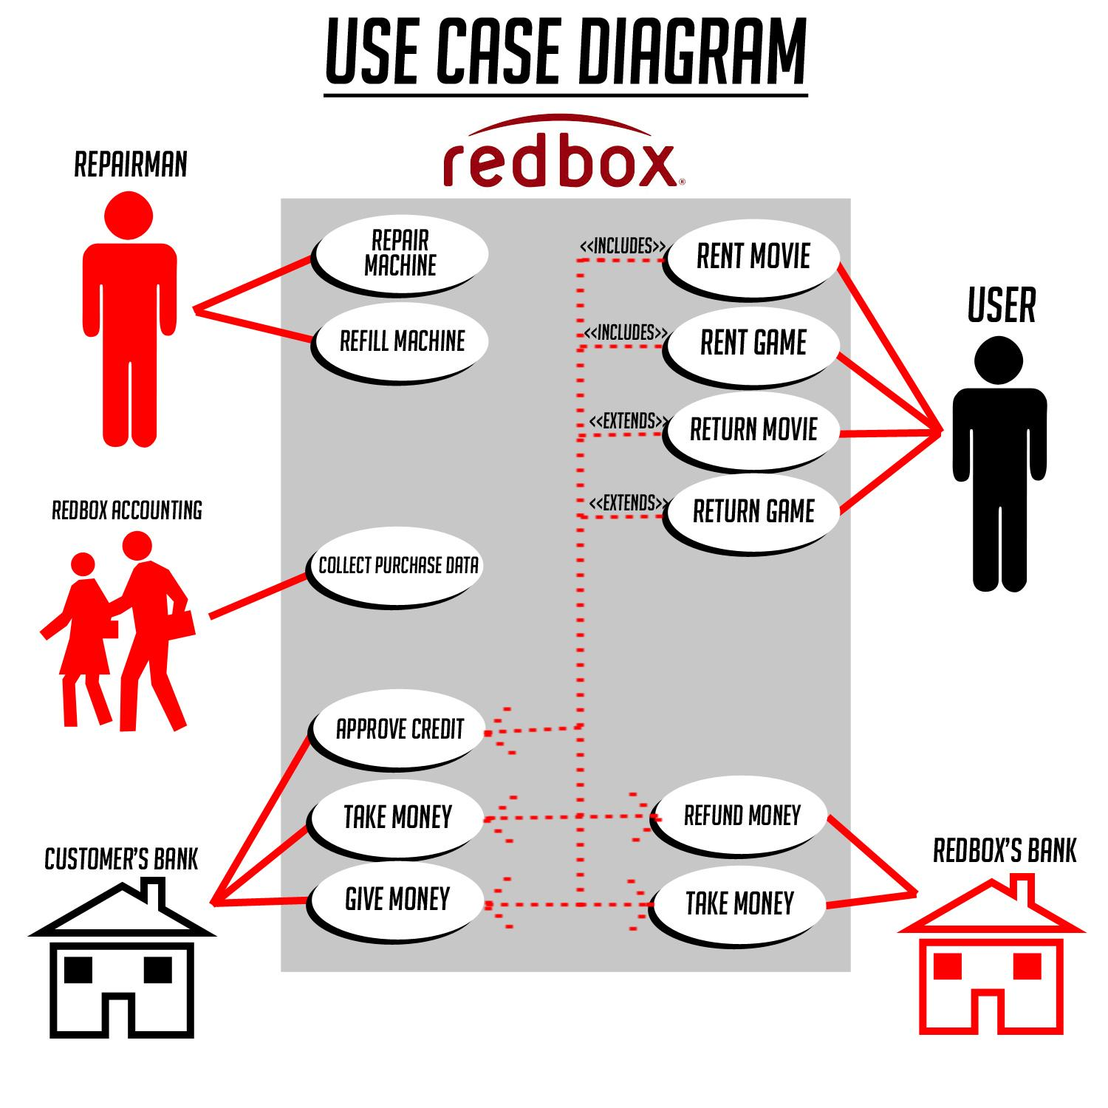

**Requirements**

User Stories:

User 1

As a user of the Redbox system, I would like to locate the Redbox easily and want the kiosk to be easy to use. The application for renting out movies/games should be easy to navigate and would like to have broad range of movies and games from various genres offered to me.

User 2

As a shareholder of the Redbox system, I would want this product to be marketed and branded well so that it attracts lot of customers, which in turn will bring me profits for my investment into this product.

Business Event Table:

1. Customer wants to rent a Movie
2. Customer wants to rent a video game
3. Customer wants to return a movie
4. Customer wants to return a video game
5. Repairman wants to fix/update machine
6. Repairman wants to add new movies/videos

Business Use Case Scenarios:

**Name - Rent Movie**

**Trigger** - Touch screen

**Business Event** - (1) Customer wants to rent a movie

**Preconditions** - Customer is near Redbox machine.

**Stakeholders** - Credit Card Company,

Customers Bank,

Redbox Bank

Redbox Accountant

**Normal steps** -

Main Success Scenario:

1. Select Movie

2. Check if movie is available

3. Calculate total price

4. Get credit card and customer info

5. Send info to server for verification

6. Charge customer

7. Record rental date

8. Set Movie return date counter

9. Retrieve movie & give to customer

10. Thank customer

**Alternatives** -

A2.1 - Ask for coupon code

A2.2 - Apply Discount to total Price

**Exceptions** -

E1.1 - Movie is not available

E1.2 - Tell customer movie is not available

E4.1 - Credit card is declined

E4.2 - Ask customer for alternative payment

E4.3 - Retry or Cancel rental

**Outcome** -

Customer is billed for movie

Movie is retrieved and given to customer

**Name - Rent Video Game**

**Trigger** - Touch screen

**Business Event** - (2) Customer wants to rent a game

**Preconditions** - Customer is near Redbox machine.

**Stakeholders** - Credit Card Company,

Customers Bank,

Redbox Bank

Redbox Accountant

**Normal steps** -

Main Success Scenario:

1. Select Game
2. Check if game is available
3. Calculate total price
4. Get credit card and customer info
5. Send info to server for verification
6. Charge customer
7. Record rental date
8. Set game return date counter
9. Retrieve game & give to customer
10. Thank customer

**Alternatives** -

A2.1 - Ask for coupon code

A2.2 - Apply Discount to total Price

**Exceptions** -

E1.1 - Game is not available

E1.2 - Tell customer movie is not available and pick another

E4.1 - Credit card is declined

E4.2 - Ask customer for alternative payment

E4.3 - Retry or Cancel rental

**Outcome** -

Customer is billed for game

Game is retrieved and given to customer

**Name - Return a Movie**

**Trigger** - Touch screen

**Business Event** - (3) Customer wants to return a movie

**Preconditions** - Customer is near Redbox machine.

**Stakeholders** - Credit Card Company,

Customers Bank,

Redbox Bank

Redbox Accountant

**Normal steps** -

Main Success Scenario:

1. Get the customer info.

2. Send info to the server for retrieving the details of the movies rented by the customer.

3. Check how many movies the customer has rented.

4. Verify whether the customer has rented the movies for appropriate time.

5. Signal the customer to put the appropriate number of DVD/DVDs in the slot.

6. Verify the DVD/DVDs returned by the customer for any damage.

7. Charge the customer for late returns/damage if any.

8. Generate the receipt in case of any charges mentioned above.

9. Update the customer’s record after the above verifications.

10. Thank Customer and tell him/her to visit again.

**Alternatives** -

A2.1 - Provide customer another coupon code/offers for next visit.

A2.2 - Offer some loyalty program. If already a member then increase his points.

**Exceptions** -

E1.1 - Machine is not functioning.

E1.2 - Direct him to another machine location.

**Outcome** -

Customer returns the DVD/DVDs successfully.

**Name - Return Video Game**

**Trigger** - Touch screen

**Business Event** - (4) Customer wants to return the video game

**Preconditions** - Customer is near Redbox machine.

**Stakeholders** - Credit Card Company,

Customers Bank,

Redbox Bank

Redbox Accountant

**Normal steps** -

Main Success Scenario:

1. Get the customer info.

2. Send info to the server for retrieving the details of the game rented by the customer.

3. Check how many games the customer has rented.

4. Verify whether the customer has rented the games for appropriate time.

5. Signal the customer to put the appropriate number of games in the slot.

6. Verify the games returned by the customer for any damage.

7. Charge the customer for late returns/damage if any.

8. Generate the receipt in case of any charges mentioned above.

9. Update the customer’s record after the above verifications.

10. Thank Customer and tell him/her to visit again.

**Alternatives** -

A2.1 - Provide customer another coupon code/offers for next visit.

A2.2 - Offer some loyalty program. If already a member then increase his points.

**Exceptions** -

E1.1 - Machine is not functioning.

E1.2 - Direct him to another machine location.

**Outcome** -

Customer returns the games successfully.

Functional Requirements:

**1. Description**: The product shall display to the customer the various movies &

games available for sale.

**Rationale**: The user must know what is available in order to buy the product.

**Fit criterion**: An average user must be able to see 100% of products available with in 3 minutes of time.

**2. Description:** The movie/game must be reliably delivered to the customer once

payment is received.

**Rationale:** This is the essential service we are providing and it must be reliable or else customers will get mad and might sue or never reuse.

**Fit criterion:** Delivery of product to customer must have a 99% success rate. Otherwise we must refund the customers money back.

**3. Description:** The movie/game must be reliably retrieved from the customer.

**Rationale:** If we do not retrieve the product back then we will incur a loss and possibly break the copyright contract.

**Fit criterion:** Retrieval of product from the customer must have a 99% success rate. Otherwise we must charge the customer for full price of the product.

**4. Description:** The product must fix or replace the movie/games if they are

damaged.

**Rationale:** The customer will not accept a defective product and will possibly not use the service again. This could result in a loss of customers.

**Fit Criterion:** 100% of games/movies must be repaired or replaced with in 2 days max once the damage is known.

**5. Description:** The product must reliably connect to the customers/Redbox bank

account.

**Rationale:** Payment from the customer must be received instantly in order to provide the service.

**Fit criterion:** Must have 98% connection rate at all times.

**6. Description:** The product must reliably connect to the Redbox Server.

**Rationale:** In order to update the database with availability and customer information we need to reliably connect to it.

**Fit criterion:** Must have 98% connection rate at all times.

**7. Description:** The product must check if products selected are available.

**Rationale:** The customer must know if the product they selected is available or not before they buy it.

**Fit criterion:** Must accurately check availability 99% of the time.

**8. Description:** The product must calculate the total amount of movies and games

selected for purchase.

**Rationale:** We must accurately calculate total prices in order to make money and not take extra from customers.

**Fit criterion:** Must be with in 1 cent of the actual price 99% of the time

**9. Description:** The product must record and keep track of purchase date.

**Rationale:** In order to prevent loss of money, the product must keep track of purchase date so that we know if they are late returning product.

**Fit criterion:** Must have record time as detailed as to the exact hour of the purchase time.

**10. Description:** The product must charge customer extra if not returned within 24

hours.

**Rationale:** If the customer does not return the movie or game with in 24 hours we must charge them for every extra day they keep the movie in order to not lose revenue.

**Fit criterion:** Must charge the customer 1 extra dollar every additional 24 hours.

**11. Description:** The product must verify the DVD/DVDs returned by the

customer for any damage.

**Rationale:** People won’t like it if the movie or game is damaged or scratched or we will lose customers and revenue.

**Fit criterion:** If the movie or game is unreadable or 10% unreadable then we must charge customer and get it replaced.

**12. Description:** The product must verify the Movie/Game if it is the same

Movie/Game they checked out.

**Rationale:** People won’t like it if the movie or game they rent is not correct or we will lose customers and revenue.

**Fit criterion:** The movie/game must have the same name and upc number when scanned in the machine as the one recorded when checked out by the customer.

**13. Description:** The product must print a receipt for customer.

**Rationale:** People need to know how much they were charged and when to return the movie.

**Fit criterion:** The receipt must contain purchase price, tax, purchase date, and return date on the receipt.

**14. Description:** The product must check customers bank account for available funds.

**Rationale:** If the customer does not have available funds in his or her account then we must not allow them to rent a game or movie because we don’t want to give them out for free.

**Fit criterion:** The bank account must have at least $1.00 available in their account.

Non-Functional Requirements:

**1. Description:** The product shall be attractive to a teenage audience.

**Rationale:** Teens and young adults are the primary market target.

**Fit criterion:** A sampling of representative teenagers shall, without prompting or enticement, start using the product within four minutes of their first encounter with it.

**2. Description:** The product shall comply with corporate branding standards.

**Rationale:** The product should look the same so customers can recognize the product in different locations.

**Fit criterion:** The office of branding shall certify that the product complies with the current standards.

**3. Description:** The product shall appear authoritative.

**Rationale:** The customers must trust the product, and be willing to trust it with credit card and personal information in order to keep and obtain customers.

**Fit criterion:** After their first encounter with the product, 75 percent of representative potential customers shall agree they feel they can trust the product.

**4. Description:** The product shall be easy for 12-year-old children to use.

**Rationale:** We want people of all ages to be comfortable using the product.

**Fit criterion:** 80 percent of a test panel of 12-year-old children shall be able to successfully complete and order process in less than 4 min.

**5. Description:** The product shall retain the buyer’s buying preferences.

**Rationale:** Saving repeated steps will retain customers.

**Fit criterion:** 75 percent of users repeat the process at a later date.

**6. Description:** The product shall be user friendly

**Rationale:** Users must find the new product easier to use than the current product, so that they make fewer errors

**Fit criterion:** The average error rate for all user input shall be less than 1.5 percent.

**7. Description:** The product shall be able to be used by members of the public who

will receive no training before using it.

**Rationale:** We want the product to be liked by all.

**Fit criterion:** 85 percent of a test panel shall successfully complete and order within 2 min.